Mast 5112

POE

Part 1 A document on how you will be designing your application in React Native

Faraaz Mahomed

ST10446912

Table of Contents

Part 1 Page 2 - 17

* A document on how you will be designing your application in React Native
* Figures/pictures
* What I must improve on

Part 2 Page 19 - 23

* Pictures
* Description of the pictures

Reference list Page 24 - 25

Part 1

A document on how you will be designing your application in React Native

HomeScreen

The HomeScreen serves as the welcoming interface of the Digital Menu App, designed to guide users to different sections with ease. It features a prominent image at the top, which sets the theme and tone of the app, followed by a header that warmly greets users. Below the header, a series of buttons are displayed in a vertical arrangement. Each button is styled with a bold color and rounded edges to attract attention and improve usability. These buttons link to other key screens: Courses, Menu, and Specials, allowing users to quickly navigate to their desired section. This layout emphasizes simplicity and accessibility, ensuring that users can find their way around effortlessly.

Figure 1

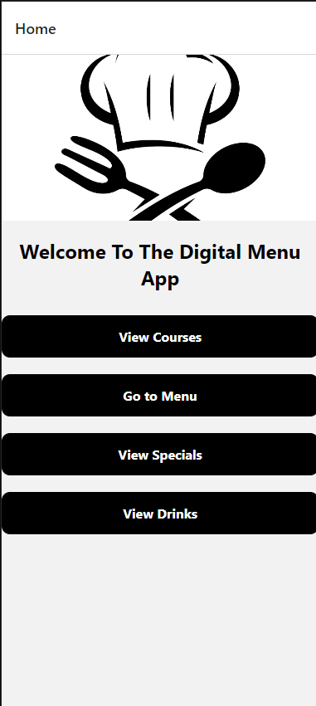

This is the homsecreen and the buttons will direct to you to the button on which you have pressed.

Figure 2

View Courses

The View Courses is designed to highlight any current promotions or courses offers available in the app. This screen typically includes visually appealing. The use of vibrant colors and attention-grabbing layouts ensures that the specials stand out, making it easy for users to spot exciting deals. The overall design is focused on creating a sense of urgency and excitement.

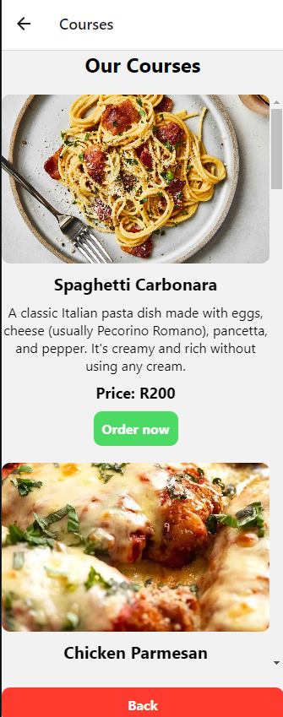

Figure 3

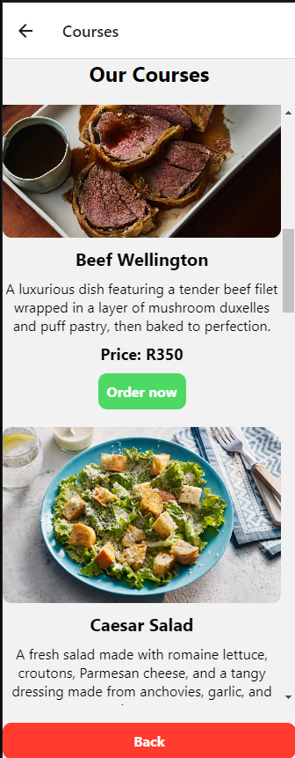

Figure 4

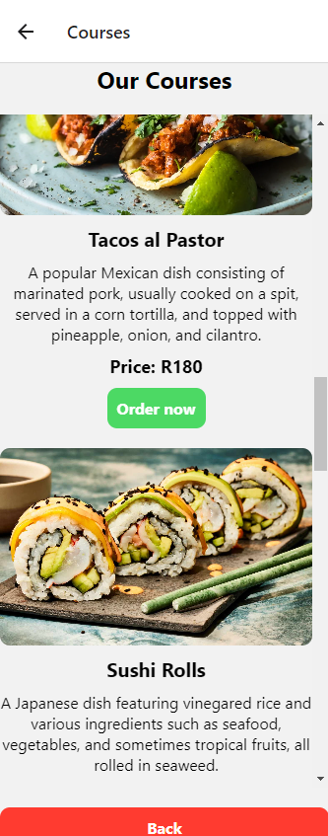

Figure 5

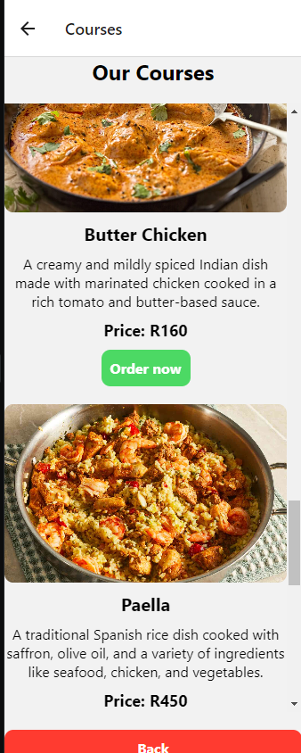

Figure 6

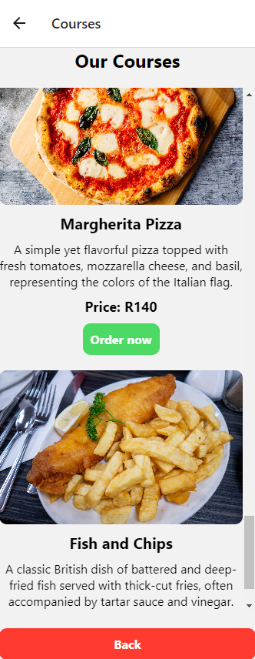

Chefs Screen

The CoursesScreen presents a comprehensive list of culinary courses available in the app. Each course is showcased with its name, a detailed description, and the price. The descriptions provide valuable insights into what each course entails, helping users make informed decisions. For instance, dishes like Spaghetti Carbonara and Beef Wellington are described with their unique ingredients and preparation methods, adding depth to the user’s understanding. The layout employs a clean and organized style, with each course item separated by white space to enhance readability. Users can interact with each course through a "More Details" button, which offers further information, ensuring that the screen remains informative and engaging.

Figure 7

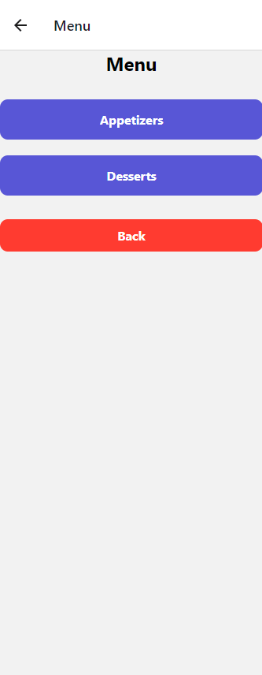

When the chef and people clicks the button appetizers you will be directed to this screen. It’s the same like the other screen where this screen the chef can only see the meals not the people.

Figure 8



Figure 9

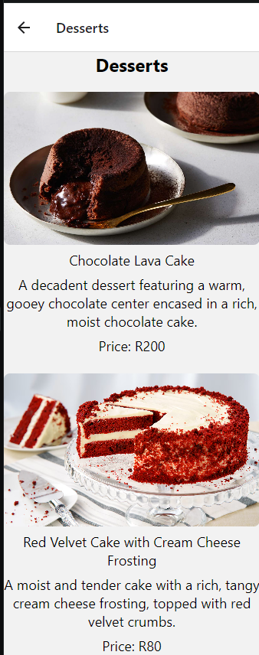

SpecialsScreen

The SpecialsScreen is designed to highlight any current promotions or special offers available in the app. This screen typically includes visually appealing banners or cards that feature the special deals, discounts, or seasonal items that are being promoted. Each special is accompanied by a brief description and an enticing image, aimed at drawing users’ attention and encouraging them to explore these limited-time offers. The use of vibrant colors and attention-grabbing layouts ensures that the specials stand out, making it easy for users to spot exciting deals. The overall design is focused on creating a sense of urgency and excitement, motivating users to take advantage of the promotions before they expire.

This is for the Specials that our store is having.

Figure 10

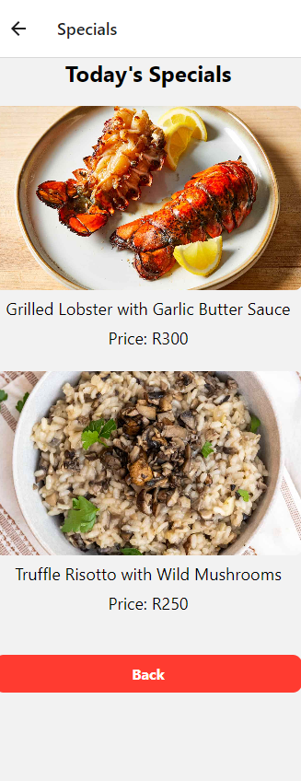

The next figures will have the drinks that our restaurant offers.

Figure 11

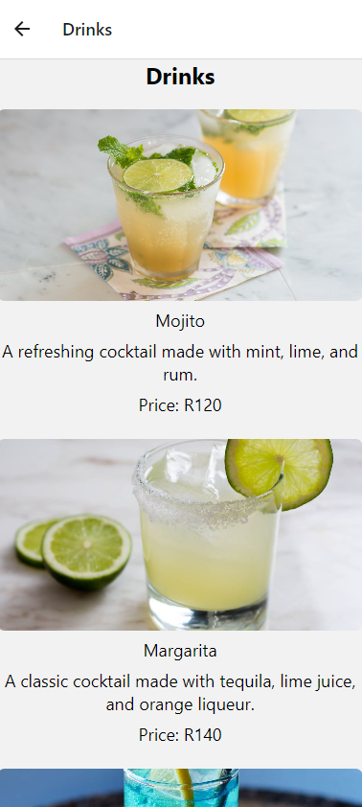

‌

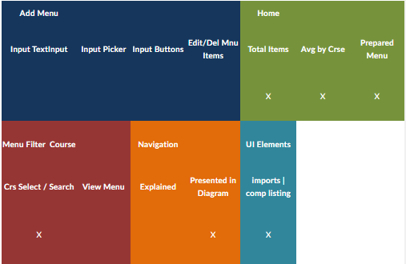

‌

Part 2 what I have fixed for the app requirements in in the POE.

Changes made for the app for the chef

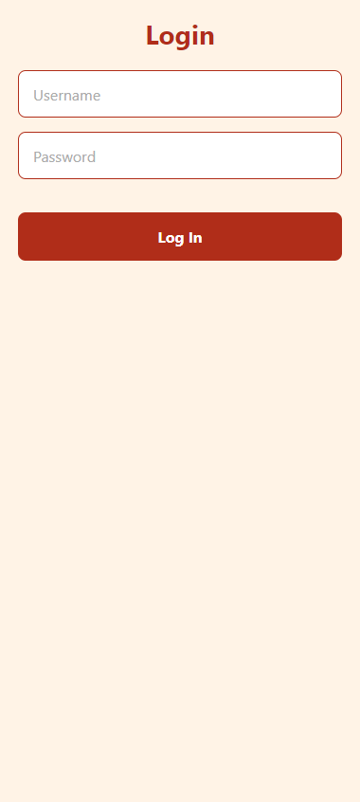 Added a login page as requested by the lecturer

Chefs menu where the chef can see what the clients has ordered

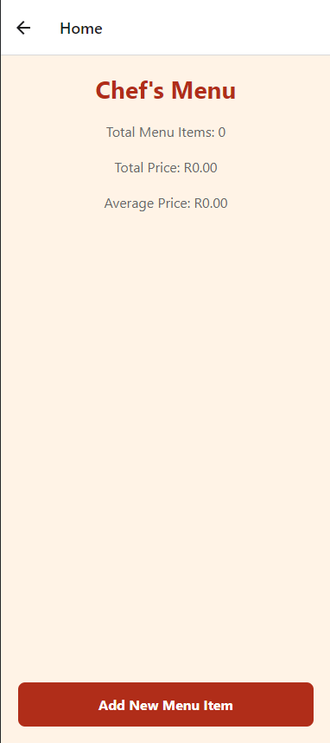

The clients/chef can add a menu item

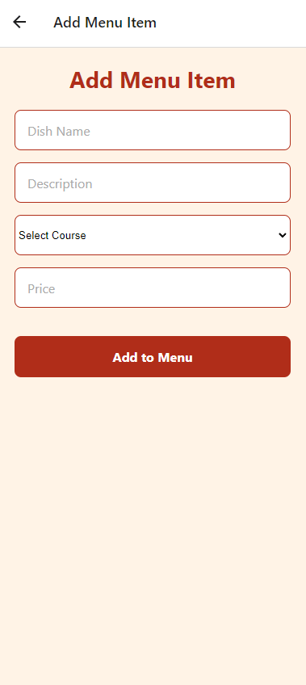

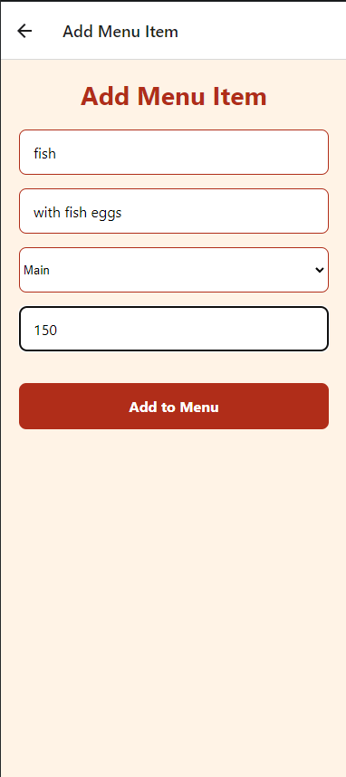

Order list what the chef can see

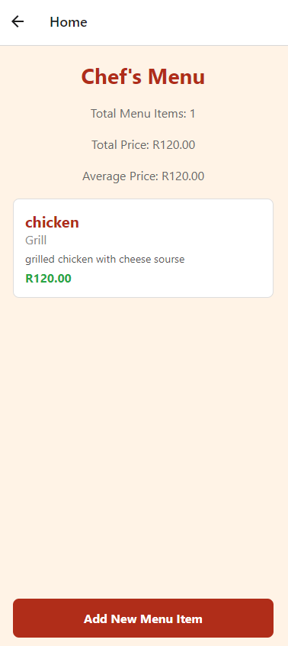

Reference List:

1. Google (2024). *Google*. [online] Google.com. Available at: <https://www.google.com/>.
2. ‌Nagi (2020). *Chicken Parmigiana*. [online] RecipeTin Eats. Available at: <https://www.recipetineats.com/chicken-parmigiana/>.
3. Allrecipes. (n.d.). *Beef Wellington*. [online] Available at: <https://www.allrecipes.com/recipe/16899/beef-wellington/>.
4. Curras, T. (2021). *Blue Lagoon*. [online] Vintage American Cocktails. Available at: https://vintageamericancocktails.com/blue-lagoon-cocktail-recipe/ [Accessed 19 Aug. 2024].

‌

1. SABRINATEE (n.d.). *Spaghetti Carbonara II*. [online] Allrecipes. Available at: https://www.allrecipes.com/recipe/11973/spaghetti-carbonara-ii/.

‌

1. Harrison, H. (2023). *Easy Caesar salad*. [online] BBC Food. Available at: https://www.bbc.co.uk/food/recipes/easy_caesar_salad_64317.

‌

1. Hill, M. (2022). *Tacos al Pastor*. [online] Culinary Hill. Available at: https://www.culinaryhill.com/tacos-al-pastor/.

‌

1. Food & Wine. (n.d.). *Dragon Roll*. [online] Available at: https://www.foodandwine.com/dragon-roll-7254587.

‌

1. Genius Recipes (2020). *Pad Thai From Kris Yenbamroong*. [online] Food52. Available at: https://food52.com/recipes/82365-best-pad-thai-recipe [Accessed 19 Aug. 2024].
2. ‌BBC Good Food. (n.d.). *Paella recipes*. [online] Available at: https://www.bbcgoodfood.com/recipes/collection/paella-recipes.

‌

1. Europe, O. (2021). *Margherita Pizza*. [online] Ooni Europe. Available at: https://eu.ooni.com/blogs/recipes/margherita-pizza.

‌

1. Wikipedia Contributors (2019). *Fish and chips*. [online] Wikipedia. Available at: https://en.wikipedia.org/wiki/Fish_and_chips.

‌

1. Food & Wine. (n.d.). *Molten Chocolate Cakes*. [online] Available at: https://www.foodandwine.com/recipes/molten-chocolate-cakes.